New Metrics to Prometheus and Grafana

* The two new metrics that were added in app_one on Prometheus:

Figure : Train-gauge metric

Figure : Test Gauge Metric

* The two new metrics that were added in app_one on Grafana:

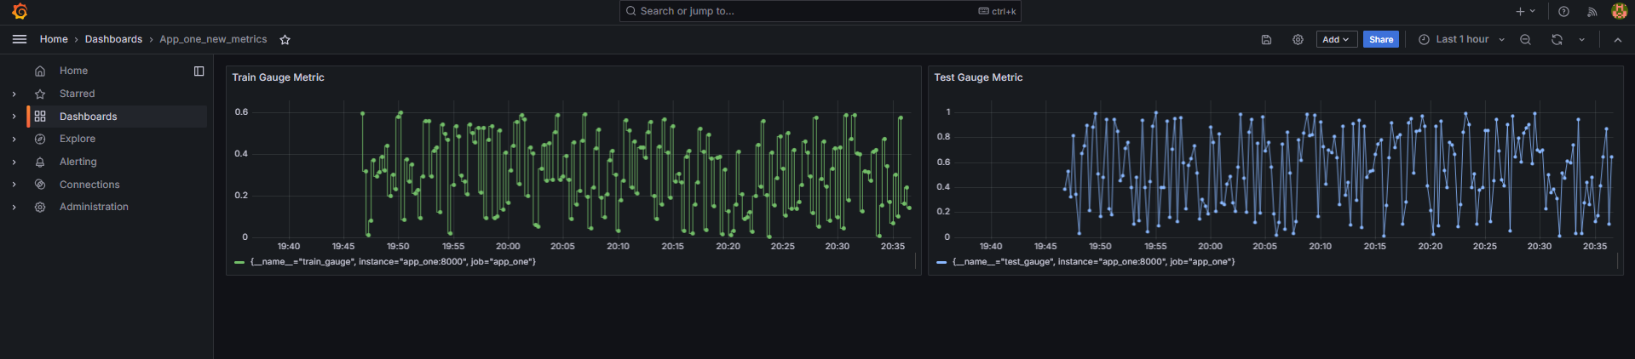Figure : New metrics on Grafana